Goals:

* Making the claw on the arm grasp onto mobile goals
* Making a clamp that can drag mobile goals
* Adding zip ties to attach the motors to the chassis
* Testing the Inertia Sensor for the programming skills challenge and autonomous period using the Moby Robots (run tests)
* Testing the GPS Sensor for the programming skills challenge using the Moby Robots (configure & test)
* Develop game strategies during the driver-controlled period

Today, Andrew and Kaitlyn attended the meeting.

Build & Program the Solution: Andrew and Kaitlyn added the fork on the top of the claw. Andrew programmed the controller to activate the fork upon pressing a button and releasing the fork upon pressing another button.

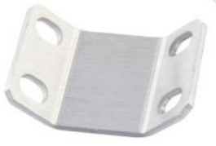

The angle part that is utilized as the fork.

Test the Solution: When testing the fork, the claw would grasp onto the mobile goal. However, when picking up the mobile goal, it would occasionally drop it or the mobile goal would fall out of place.

We needed to order rubber bands to add tension to the arms, allowing them to stay up; shaft collars for locking axles; gussets for the forks of the claws; and zip-ties for the motors. Below are the parts needed to be ordered.

* (1) Latex Free Rubber Band #32 (20-pack) (275-1089)
* (1) Latex-Free Rubber Band #64 (10-pack) (276-3990)
* (1) Silicone Rubber Band #32 (10-pack) (228-6633)
* (1) Silicone Rubber Band #64 (10-pack) (228-6634)
* (1) Shaft Collar (16-pack) (276-2010)
* (2) 90-Degree Gusset Set (4-pack) (276-2577)
* (1) 11" Zip Ties (100-pack) (275-0125)